1. Load the database city into the inspections collection.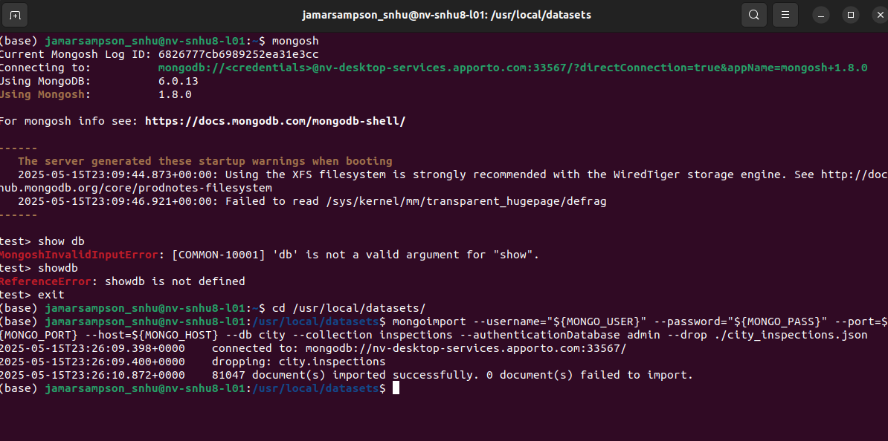

2. Verify the load by using the “city” database & issue queries.

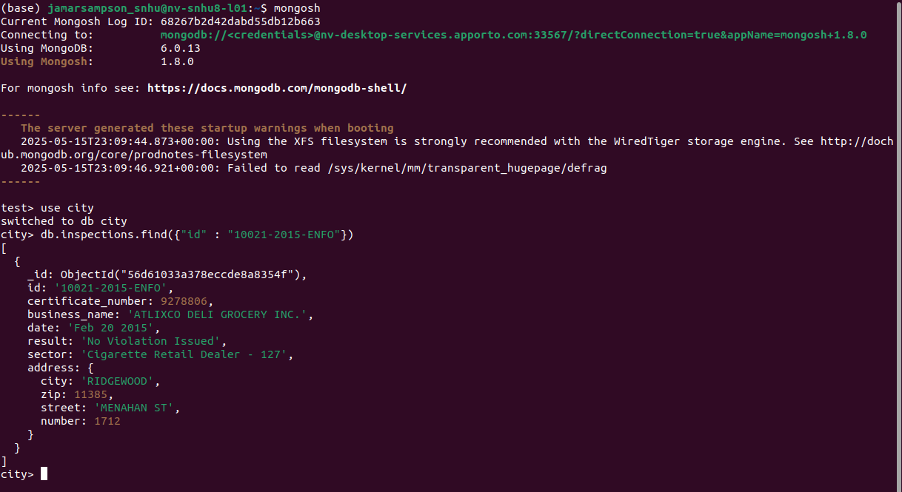

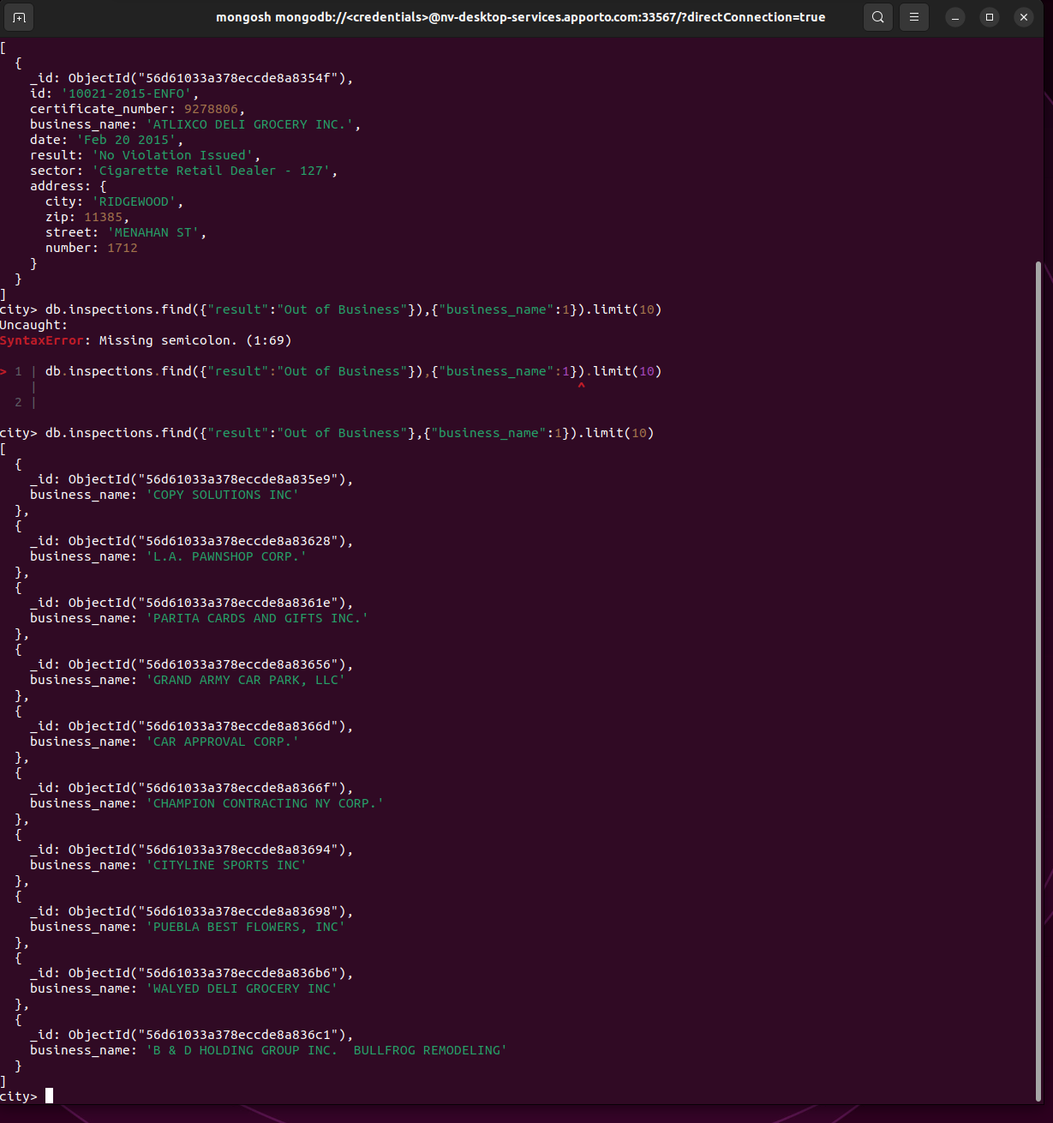

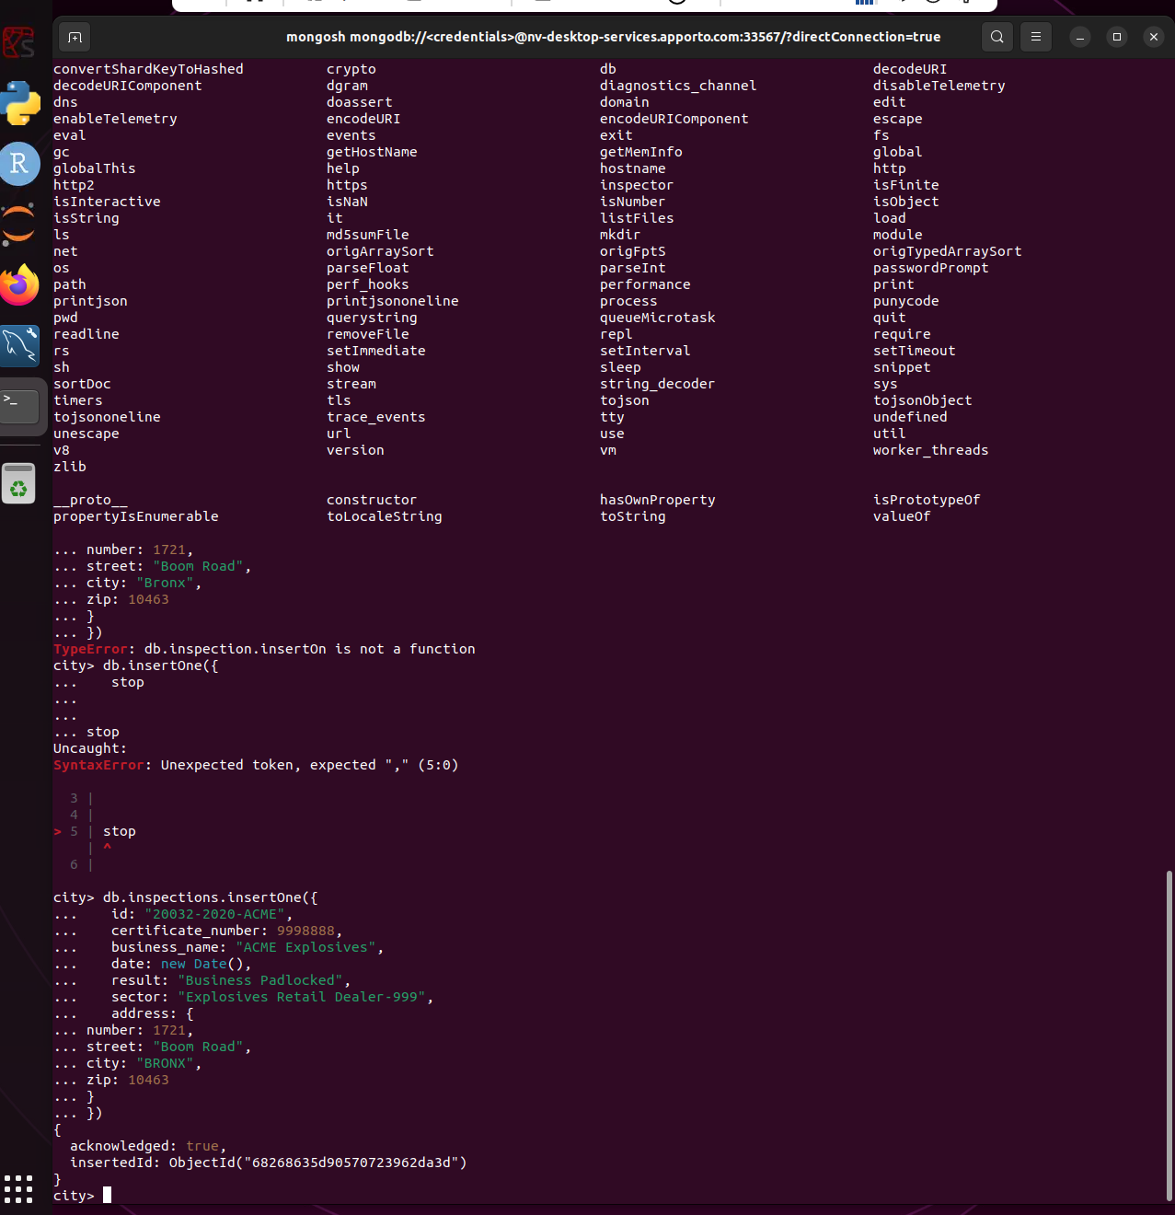



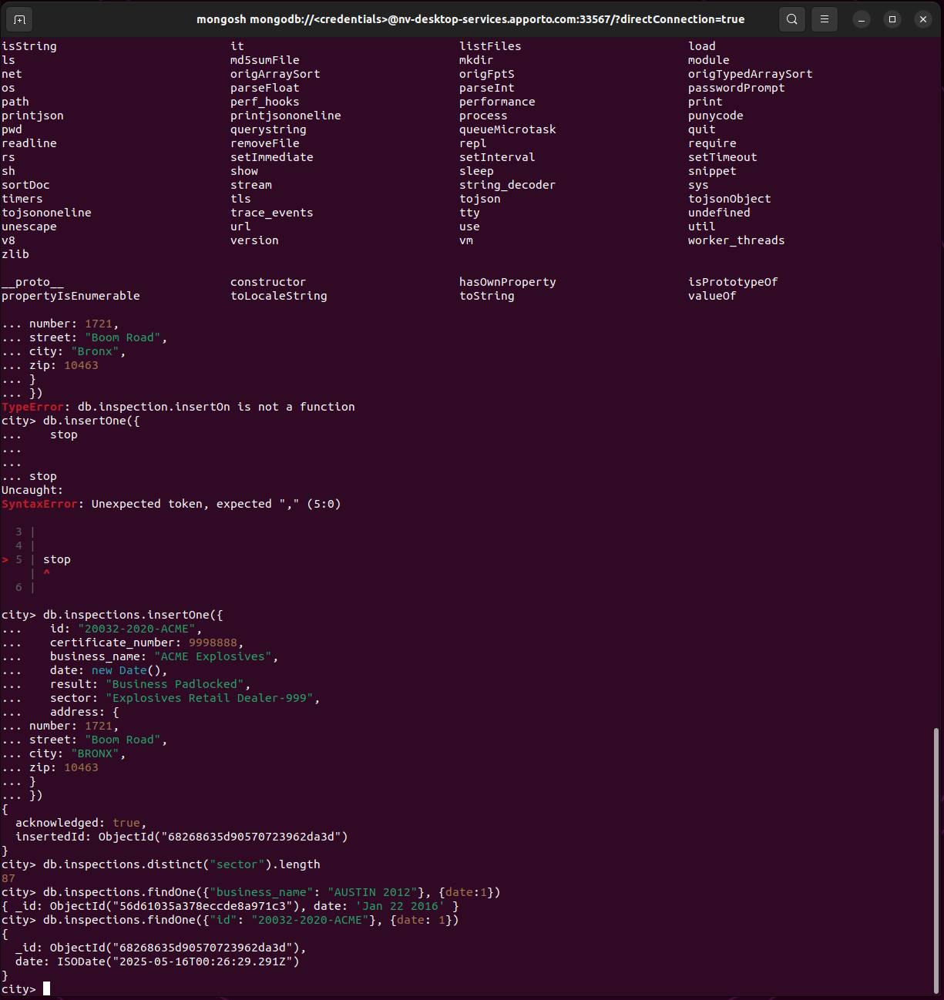

3. Verified the database & its creation using the findOne() in the screenshots above.

4. The date listed for “AUSTIN 2012” is written in a string formula. The “ACME Explosives” was written in a more detailed layout using ISODate format.

There were 13823 businesses in the database that had a Violation issued. 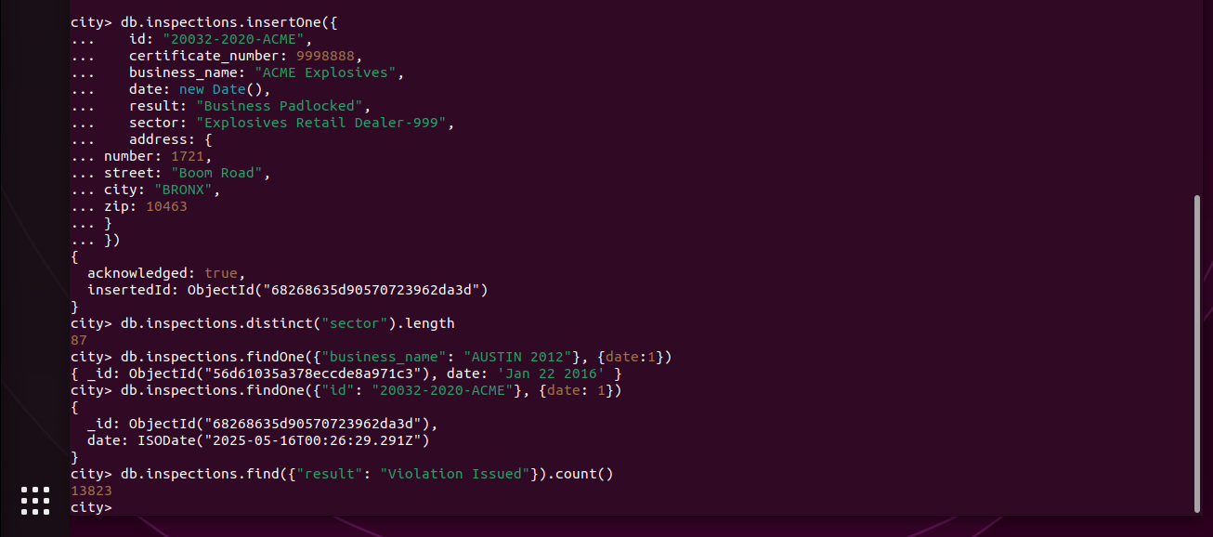

5. Updated the document with the new ID for ACME Flowers.  
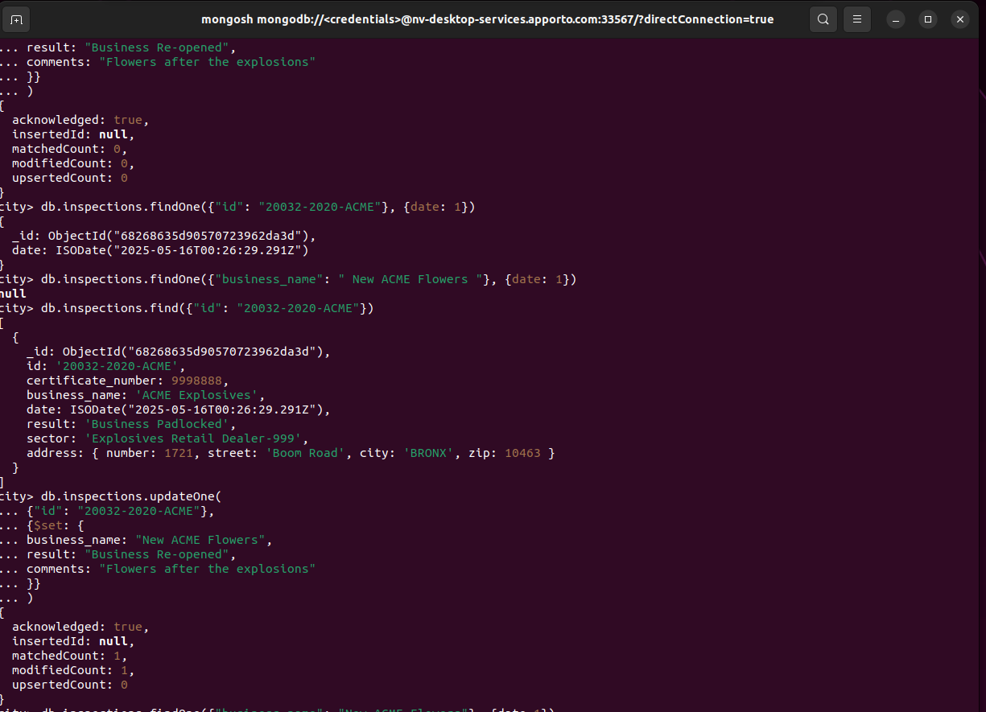

6. Updated the documents with the new zip code 76114.

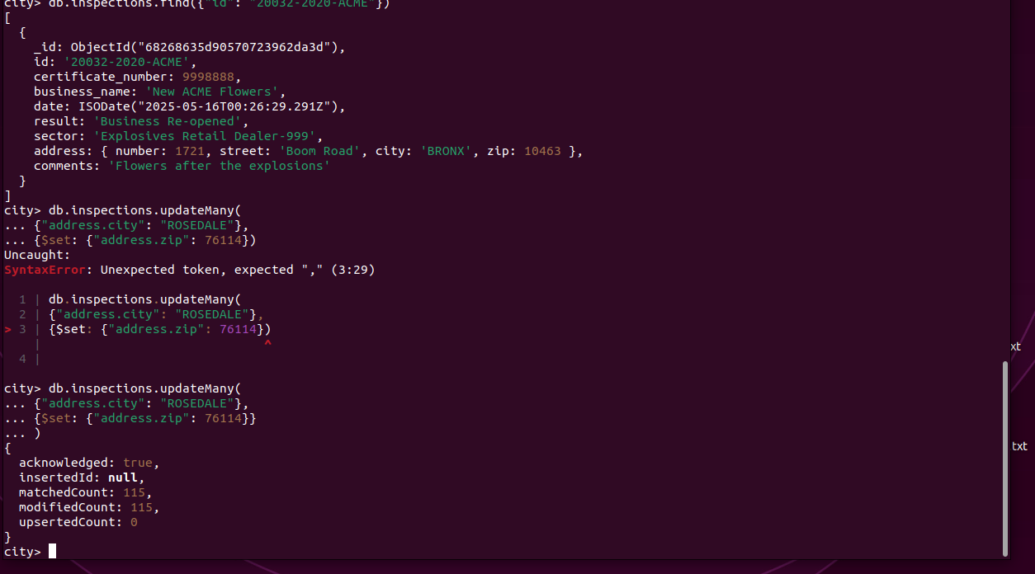

Removed the first document with the key-value “result” “Violation issued”.

